Regional Entrepreneurial Ecosystem scan
Section I: COVID issues and reaction at a glance
Issues arising from COVID | How region responded
e.g. Lockdown, Company closure, Down Sizing, New business models etc.  - Initial 6 week lockdown | e.g. emergency stakeholder response team formed, new grants etc.  - Established region multi-stakeholder response team

Section II: Region Ecosystem Overview – Pre and 22 months post COVID
For column 1 (Pre COVID) can you please provide a summary of:
- what support was available for each box. You can complete this by providing a narrative for each one, provide a list of the supporting organisations for each category;
- map the list of activities of support for all categories on a separate page;
- list any reports and/or statistics that you have available to you for each category. For example, there may be a public report that tells us how many and what type of start-ups were supported in the region and so on.
For column 2 (Post COVID) can you again please provide a summary of:
- what has changed for these supports (a narrative may be used here);
- what emergency supports were provided in the region;
- was a COVID emergency support group set up in the region and who was on it e.g. public policy makers, education, private industry etc.
- provide a list of COVID-19 impact reports by your region, national government, cities, consultancy companies etc).

- Pre-startup stage
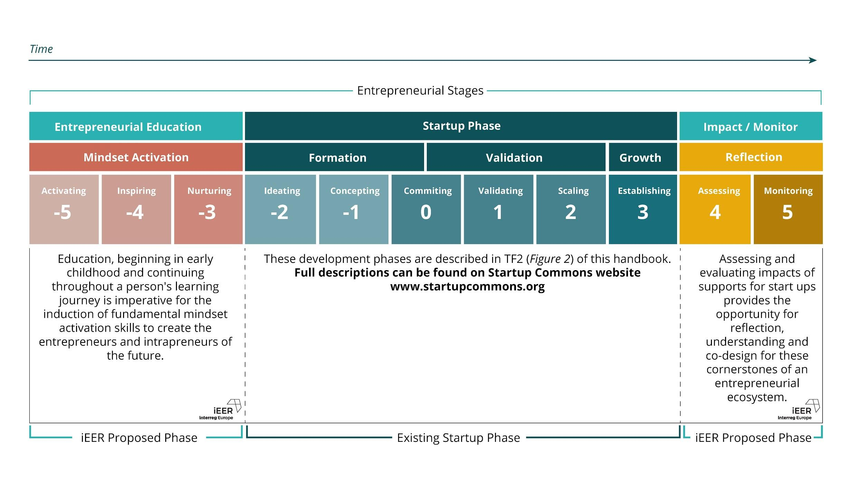
 | Pre COVID | 22 months post March 2020
Support for Entrepreneurship Education
- Primary level
- Secondary level
- HEIs
Support for Start Ups
- Financial
- Mentorship
- Level of interoperability of public services at local, regional, national and European level is crucial
- Types of start-ups supported (can use sectors to describe this)
Monitoring of Start Up Activity
- Who does this?
- How often is it done?
- How is it done?
- How is it shared?
Support for Digital Infrastructure
- Is there a strategy in the region?
- Who is responsible?
- Who contributes to the plan?
- How is the plan shared?
- Start-up stage
 | Pre COVID | 22 months post March 2020
Support for Entrepreneurship Education
- Primary level
- Secondary level
- HEIs
Support for Start Ups
- Financial
- Mentorship
- Level of interoperability of public services at local, regional, national and European level is crucial
- Types of start-ups supported (can use sectors to describe this)
Monitoring of Start Up Activity
- Who does this?
- How often is it done?
- How is it done?
- How is it shared?
Support for Digital Infrastructure
- Is there a strategy in the region?
- Who is responsible?
- Who contributes to the plan?
- How is the plan shared?
- Post-startup stage
 | Pre COVID | 22 months post March 2020
Support for Entrepreneurship Education
- Primary level
- Secondary level
- HEIs
Support for Start Ups
- Financial
- Mentorship
- Level of interoperability of public services at local, regional, national and European level is crucial
- Types of start-ups supported (can use sectors to describe this)
Monitoring of Start Up Activity
- Who does this?
- How often is it done?
- How is it done?
- How is it shared?
Support for Digital Infrastructure
- Is there a strategy in the region?
- Who is responsible?
- Who contributes to the plan?
- How is the plan shared?
Section III: Future of the Region Ecosystem
Regional Self-Assessment
Does a process exist? If yes please describe.
Does the region align entrepreneurial activity to UN SDGs? If yes please describe

Future Trends
Is there a local recovery plan in place for your region? Please describe and provide link if possible.
What are the future trends for entrepreneur support in your region?
E.g are there any areas of specialisation that will
suit the needs of your region?

