
D.T 1.5.1 - D.T 2.5.1
Methodology for action plans  development | Final Version  11/2018


Table of contents

1.Executive summary 3
2. From analyses to actions 4
3. Structure of the Knowledge Tool 7
4. Structure of the Action Plan 8
5. Partners’ specific tasks 10

1.Executive summary
A sound framework of analyses has been developed as first step of TalkNET implementation. The analyses have outlined gaps of infrastructures, organization, technologies, services etc.
The built knowledge has a strong value for the whole programme area increasing the culture of logistics status quo and the improvement needs. Nonetheless, in order to support concrete actions among stakeholders a further step is necessary: limiting the field and clearly defined the actions to be taken.
For this reason, knowledge tools have to be prepared in order to be easily readable and understandable by stakeholders. Furthermore, on the base of them specific action plans have to be defined.
During the analysis phase, PPs were involved in a transnational consultation process with stakeholders aimed at defining how to deal with the five topics outlined in the project framework. The knowledge tool has to describe the relevant knowledge acquired both from inside and outside the partnership proposing advanced solutions in terms of good practices. Examples are indeed the most simple way to show that a determine conditions can be overcome towards a more sustainable solutions.
How to transfer and implement such good practices is the focus of the action plans.
TalkNET cannot overcome all the aspects that can be detected in the analyses phase. Nonetheless, the relevance of the partnership and the stakeholders involved till this level of implementation has to provide concrete answers to some of the issues considered.
The methodology and the suggested table of contents has to be necessarily generic considering the range of possible intervention taken into consideration.
Indeed, in order to support the change of a predetermined condition the actions could imply testing, works, new services, technology deployment etc. The more complex the action considered is, the more the knowledge tool and the action plan will have to be elaborated.

2. From analyses to actions
In a simplify logical consequence, a clear view of stakeholders’ needs is the base to look for transferable good practices. “Transferable” means that with specific interventions the solutions can be implemented and drive to a more sustainable transport and logistics solutions. The description of the challenge to face can determine a series of very different corrective measures that can comply legislative proposals, infrastructure interventions, technological improvement etc.
Here below a summing up of the suggested scheme:

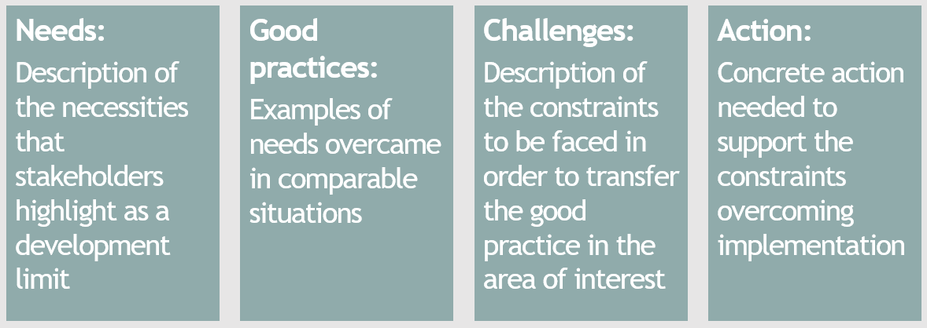

The logical framework has to be followed by every partner considering the specific interest and commitment taken in the project framework. As for example, an analysis implemented in cluster 1 should drive to needs identification, good practices, challenges and related actions always related to the cluster 1. The process can be seen as a matrix organised as “ordinate=cluster” and “abscissa=fields to complete”.
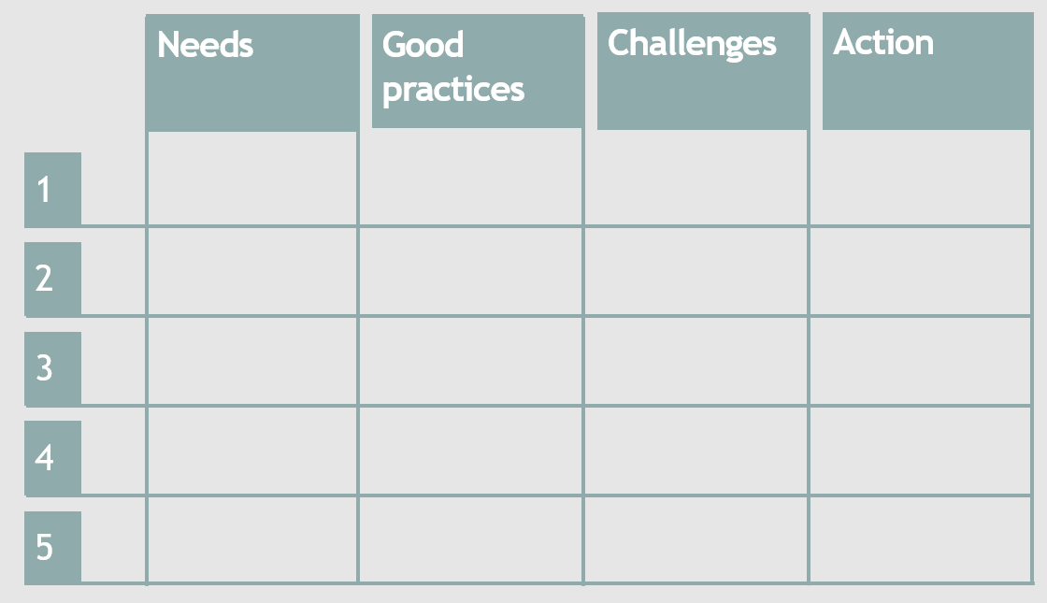
As practical example, a partner could identify a specific need to face and a related good practice in the framework of alternative fuels topic. As a logical consequence, challenges and actions should deepen the same field as shown below.
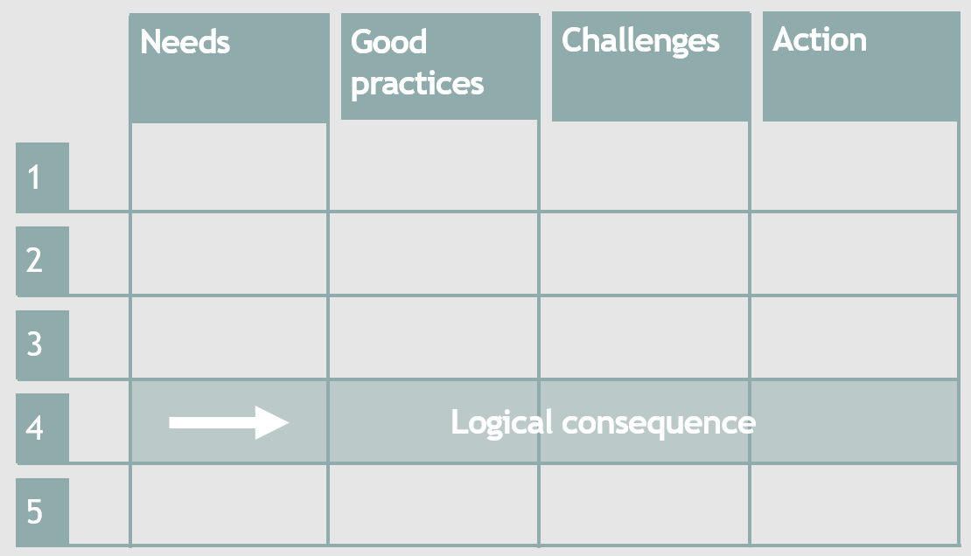

At project level, the knowledge tool will comply all needs and good practices deepened by the partners.
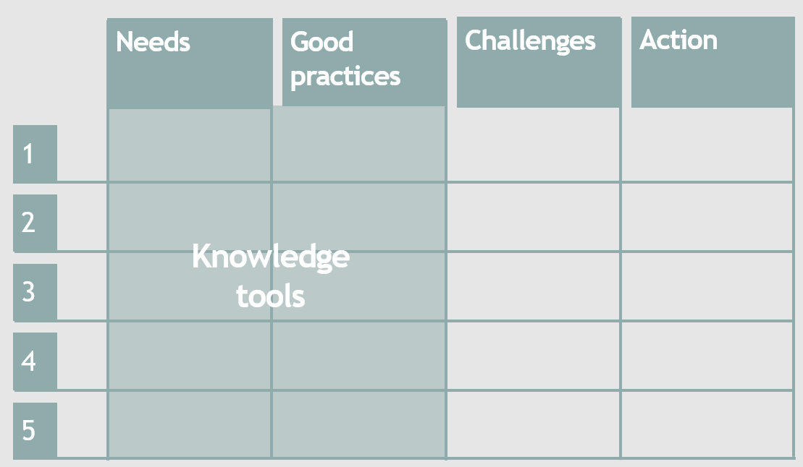
While the description of challenges and the actions suggested will compose the action plans.
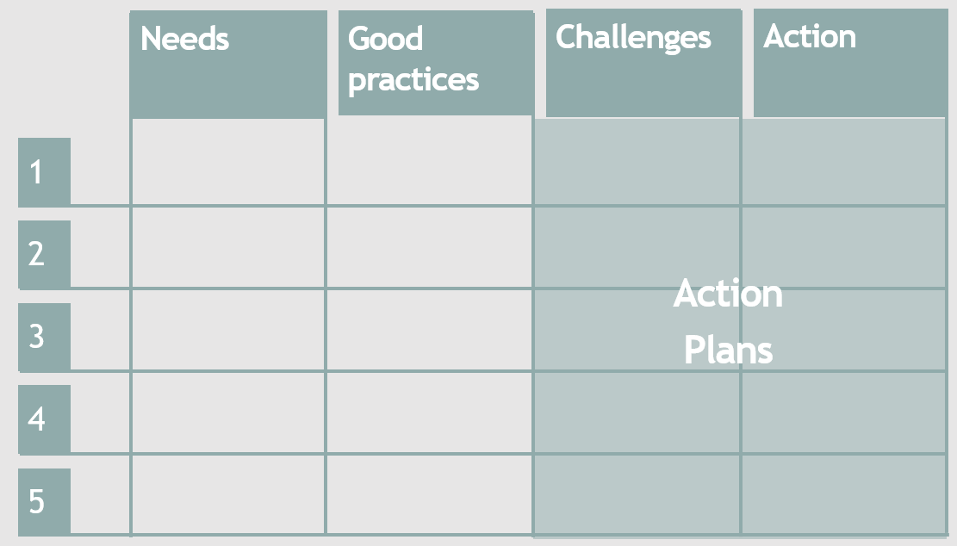

The matrix has to be considered as a guideline to follow in order to assure a linearity from the analysis phase towards the implementation of pilot actions expected in WPT3.
As a further support, specific table of contents has been developed in the next chapters.

3. Structure of the Knowledge Tool
Knowledge Tools (KMT) consist of a logical instrument to effectively grouping, systematizing, archiving, recovering and managing information both internally and externally an organisation regarding a specific process or situation under analysis. This kind of instrument might represent the way to troubleshoot the lack of missing of information within a process or a specific situation. From a general point of view, the KT is based upon a preliminary set up database from which relevant information are retrieved according to specific criteria.
The use of a KT allows to focus on a specific issue implementing an in-depth analysis, considering the following logical steps:
- needs identified as relevant for the partner or/and the stakeholders expressing an interested for the issue;
- problems deriving from non-satisfaction of the needs preliminary identified, hampering the optimization of a specific process or /and situation;
- identification (if any), of past attempts to remove, mitigate or solve the problems above-mentioned, offering suitable solutions;
- identification of the weakness affecting the past attempts;
- mapping of feasible good practices implemented in order to give answer to the same or similar needs in a comparable context. Good practices identified can refers not only to cases implemented within the CE programme are but in general, provided that the needs and the context can be brought back and then compared to your punctual situation under analysis;
- systematization in order to achieve a clear overview of the elements charactering the good practices identified and their analysis in order to find out key elements or/and processes that can be adapted to your situation in order to provide feasible solutions.
For needs, it is meant the necessities identified internally or externally, by your stakeholders, to which it is not possible to provide a credible answer without implementing a serious of actions aiming at solving weakness or/and obstacles.
A good practice can be seen as an example of someone with the same needs that was able to satisfy them. Accordingly, it is a method, model or technique that has been accepted as superior to several alternatives because it produces results that are superior to those achieved by other means or because it has become a standard way of acting.
Points from 1 to 6 above-mentioned have to be regarded as a table of content for the draft of the KT according to a logical path. More in detail, the structure to follow is:
- description of the key elements of the needs (minimum 2000 characters);
- description of past solutions (if any), already implemented (minimum 1.500 characters);
- description of each good practice identified (minimum 4000 characters), reporting at least the following items:
  - general overview of the practice;
  - motivation for considering the solution proposed;
  - explanations of why the solution proposed is considered as replicable and adaptable to your specific context.

All characters indications have to be considered as min length . The contents length can be very different from one partner to the other considering the specific area of interest.

4. Structure of the Action Plan
An Action Plan (AP), is a detailed plan outlining actions needed to reach one or more goals. Alternatively, it could be defined an action plan as a sequence of steps that must be taken, or activities that must be performed well, for a strategy to succeed.
AP should break down the strategy goals and objectives into specific tasks related to previously identified challenges upon which a specific strategy has been developed applying an “intervention logic” scheme. It should include the sequence of steps to be taken, or activities that must be performed, for a strategy to succeed and producing a positive change. Therefore, it should include a set of tasks, a time line, the financial resources and a definition of the responsible actors for the good practice transferability.
Key element composing an Action Plan:
- identification of the main challenges to be addressed by the AP;
- results to be achieved;
- tasks to be performed in order to achieve expected results;
- key actors to be involved per task, explaining the level of involvement and the relevance of their participation;
- timeline;
- expected results description both in qualitative and quantitative terms.

Points from 1 to 6 above-mentioned have to be regarded as a table of contents for the draft of the AP, according to a logical path. More in detail, the structure to follow is:
- description of the main challenges tackled (minimum 3000 characters);
- definition of the results to be achieved (minimum 500 characters per goal);
- set of tasks to be performed to achieve the expected outputs (minimum 4000 characters, including a brief overview and a list of action per bullet points);
- key actors (minimum 500 characters per actors);
- timeline of the list of tasks foreseen in the form of a GANTT;
- expected results (3000 characters, including both quantitative and qualitative).
All characters indications have to be considered as min. length. The contents length can be very different from one partner to the other considering the specific area of interest.
Being key project outputs, the action plans are expected to determine a clear impact by:
1 – Supporting pilot actions implementation WPT3
2 – Supporting partners’ planning tools
In the first case, the action plan should explain and support the pilot action chosen for every cluster providing a clear and exhaustive work flow.
In the second case, the action plan should follow the characteristics and peculiarities of the single planning tool used by TalkNET’s partners as for example an industrial plan for private players or the three/four years planning for public bodies. Such a result is indeed the most relevant impact expected by the action plans.

5. Partners’ specific tasks
Accordingly with the internal clusterisation, partners are called to deepen their specific fields of interest and competence following the scheme below. The table below has not to be seen as a limitation but as a minimum content to be delivered. Indeed, the analysis phase could have slightly modified the approach and objectives of the partners.

PARTNER (PP) | CLUSTERS TO BE ADDRESSED
PARTNER (PP) | 1 | 2 | 3 | 4 | 5
1 – PORT OF VENICE (LP) |  | X | X | X
2 – PORT OF TRIESTE (PP) |  |  |  |  | X
3 – VENETO STRADE (PP) |  | X | X
4 – ZAILOG (PP) | X |  | X | X | X
5 – LUKA KOPER (PP) | X | X | X |  | X
6 – PORT OF RIJEKA AUTHORITY (PP) | X | X | X |  | X
7 – RAIL CARGO HUNGARY (PP) | X | X |  | X | X
8 – FREEPORT OF BUDAPEST (PP) | X | X | X | X | X
9 – PORT OF BRATISLAVA (PP) |  | X | X |  | X
10 – WESTPOMERANIA REGION (PP) | X |  |  |  | X
11 – SZCZECIN AND SWINOUJSCIE (PP) |  |  | X
12 – REGIONAL DEVELOPMENT AGENCY OF USTI REGION (PP) | X | X | X | X | X
13 - LOKOMOTION (PP) | X |  | X |  | x
14 - CHAMBER OF COMMERCE MUNICH |  |  | X
15 - CODOGNOTTO POLAND (PP) |  |  | X | X

