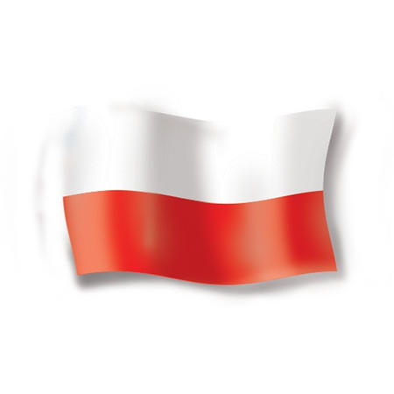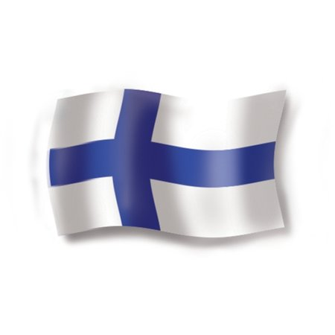
PRELIMINARY AGENDA !

seminar programme
”CLUSTERS AS A TOOL FOR INNOVATION IN EUROPE”
Date: Helsinki, June 11th, 2012 Venue: Helsinki Exhibition & Convention Centre, Messuaukio 1, FI-00520 Helsinki, room: 208
Time | Detailed programme
9:30 – 10:00 | Registration and distribution of the Seminar materials
10:00 – 10:15 | - Opening address by Mrs. Ilona Antoniszyn-Klik, Undersecretary of State in the Ministry of Economy  - Speech by Mr. Jouni Hakala State Secretary in the Ministry of Employment and the Economy
10:15 – 10:30 | - Speech by the FINPRO President/VicePresident – “The application and use of innovated technology in Finland” ……………..
10:30 – 10:45 | - Presentation “Polish clusters, clusters policy in Poland and its internationalization” given by …………… – the President/Vice President of the Board of the Polish Agency for Enterprise Development (PARP)
10:45 – 12:15 | - Short presentation given by the representatives of the selected Polish and Finnish clusters (few slides each).  (Main sectors: environment, IT, electronics, nuclear and renewable energy, health, medicine, new efficient technologies in the construction industry)
12:15 – 12:30 | - Questions & Answers session
12:30 – 13:45 | - Lunch
13:45 – 16:00 | - Face-to-face business talks

